# Kispiox Band – Anspayaxw Information Document for the Proposed Designation of

**1537 Thunder Road, Lot 78 of the Kispiox Indian Band Reserve No. 1 LAND DESIGNATION**

**BACKGROUND**

The Chief and Council of the Kispiox Band (“Kispiox”) are providing this information document as an overview of the proposed designation for the lease of the following parcel of land located on Kispiox Reserve No. 1 (the “Reserve”). This document explains the designation process and provides information about the proposed use of the lands. It is one component of the community information process that along with community information meetings and other documents will allow Kispiox members to make an informed decision about the proposed designation.

The vote will be successful if 50% plus 1 of the votes cast are in favour of the designation.

# LEGAL DESCRIPTION OF THE DESIGNATION LANDS

The following parcel of land constitutes the lands proposed to be designated for the longhouse and other purposes:

In the Province of British Columbia

In Cassiar District

In Kispiox Indian Reserve No. 1

All of Lot 78 shown in Plan 113078 recorded in the Canada Lands Surveys Records in Ottawa

Containing 0.429 hectares

(the “Designated Lands”)

A map of the Designated Lands is set out in Appendix ‘A’.

**WHAT IS A DESIGNATION?**

Canada holds legal title to the Reserve for Kispiox Indian Reserve No. 1. Designating lands in the Reserve allows Canada to lease them to non-members (usually a company, including a company owned by Kispiox) for Kispiox’s financial benefit.

A designation is technically a “non-absolute surrender” under a process set up by the *Indian Act* and the *Indian Referendum Regulations*. **Designated lands do not lose their reserve status**. They remain part of the Reserve and are only available to be used for the purposes authorized by the designation and only for the limited period established by the designation. Valid Kispiox by-laws apply to designated lands and income earned by Kispiox or its members on designated lands is usually not taxable.

Council, with the assistance of its lawyers and advisors, will do most of the negotiating of legal documents for projects to be developed on the designated lands, though any documents that need to be signed by the legal title holder (Canada) will need to be on terms acceptable to both Canada and the Council.

# PROPOSED TERMS OF DESIGNATION

# The proposed Designation Document is attached to the Referendum Notice and is included in the mail-out package to off-reserve electors. It has more detail than this Information Document as this is meant to be more of an overview

**Purpose**: The Designated Lands may be leased for

1. a longhouse centre that provides services for Gitxsan families and children, including residential care and support services for health, wellness, cultural and social purposes (the “Approved Project”); or
2. recreational, residential, institutional and commercial-retail (the “Future Projects”).

The Future Projects category is intended to be broad to give Kispiox the flexibility to attract the best possible developments for the designated lands. Once a more specific Future Project proposal is known, Council will present it to Kispiox’s voters under Kispiox’s member consultation process.

**Term**: The proposed designation will be for a term of **99 years.**

**Rent:**

An appraisal of the Designated Lands was prepared by Penny & Keenleyside Appraisals (the “Appraiser”) on May 28, 2024. The Designated Lands were appraised as if fee simple, and the highest and best use was determined to be residential use. The Appraiser determined that the fair market rent for the Designated Lands is $4,201 per year from the effective date of May 28, 2024. This rate will be used for the five years following the effective date. Copies of the appraisal are available for viewing at the Kispiox Band Office.

Leases to corporations, limited partnerships, or other entities that are not 100% beneficially owned by Kispiox will pay at least fair market rent.

Corporations, limited partnerships, or other entities 100% beneficially owned by Kispiox First Nation (a “Nation Entity”), such as the Anspayaxw Wellness Society (the “Society”), will pay Canada a prepaid nominal rent in the amount of $10.00 for the entire term of the lease, which means that Canada will not collect any rent or credit any rental amount to Kispiox’s revenue account. Council anticipates that, instead, the Nation Entity will generate at least fair market rent by subleasing the Designated Lands. Any use of the Designated Lands leased to a Nation Entity comes with some risk that Kispiox will ultimately not receive as much money for the Designated Lands as it would have received had there been a lease to a non-Nation Entity for fair market rent. Canada requires the members to acknowledge this risk and other risks around leases for less than fair market rent. These acknowledgements are set out in the Designation Document.

Canada will only collect rent payable under any fair market rent headleases (which it credits to Kispiox’s revenue account managed by Canada) and not rent payable under any subleases which is the tenant’s responsibility to negotiate and collect.

**Environment**:

An environmental assessment of the lands was prepared by WSP Canada Inc. and dated April 30, 2024. Copies of this document are available at the Band Office.

Before any project goes ahead, current federal law requires an environmental review of the project. This process may indicate that certain mitigation measures should be incorporated into the project in order for it to proceed so that it does not cause significant adverse environmental effects. In that case, they will be made part of the requirements under the lease for that project.

**Projects Currently Under Consideration:**

At present, the Band proposes to lease the Designated Lands to Anspayaxw Wellness Society, a non-profit Society beneficially-controlled by the Band (see section on “Information About the Society” below).

Anspayaxw Wellness Society proposes to sublease the Designated Lands to Gitxsan Child and Family Services Society (the “GCFSS”) at fair market rent. The GCFSS is a not-for-profit registered society in British Columbia. The GCFSS serves five of the six Gitxsan Nation communities including Kispiox, Glen Vowell, Gitwangak, Gitsegukla, and Gitanyow. Gitanmaax, the sixth Gitxsan community, is not a beneficial member of the GCFSS but has for the purpose of supporting the Longhouse initiative, signed a Memorandum of Agreement.

GCFSS plans to develop a longhouse centre to provide residential care and support services for health, wellness, cultural and social purposes to Gitxsan families and children (the “Longhouse”). The Longhouse proposed to be built by the GCFSS will provide culturally appropriate support for Gitxsan children in care, youth aging out of care, and single support parents and children fleeing from violence.

The Society will ensure that the improvements on the Designated Lands are maintained in good order and repair and insured.

# INFORMATION ABOUT THE SOCIETY

To assist in Kispiox’s community development, the Chief and Council will establish the Anspayaxw Wellness Society in 2025. The Society will be a non-profit Society beneficially-controlled by the Kispiox Indian Band under the *British Columbia Societies Act*. The purposes of the Society are to provide programs and services to Kispiox members and other Indigenous peoples within the traditional territory of the Gitxsan Nation, as follows:

1. to develop and implement programs and services that support physical, emotional, cultural, and spiritual well-being;
2. to operate programs and services that provide culturally appropriate counselling and treatment programs, including live-in or bed-based facilities for alcohol and drug use, dependency, and recovery;
3. to improve the health of community members;
4. to provide food security programs and services, including foodbanks, that support the maintenance of homefullness;
5. to provide quality, safe, and affordable on and off-reserve housing opportunities;
6. to fund, develop, own, and manage housing units;
7. to undertake housing renovation and rehabilitation projects to improve the quality of available housing, including off-reserve and urban housing projects and initiatives;
8. to coordinate and work with other First Nations and any other government or legal entity, including the Gitxsan Child and Family Services Society, BC Housing on projects, initiatives, planning and research on methods and plans to increase access to housing;
9. to enter into any agreement or arrangement with any government or other legal entity, including First Nations, the Gitxsan Child and Family Services Society, BC Housing and any other organization that may be conducive to the Society's purposes and to comply with any such agreement or arrangement;
10. to accept and solicit funds, equipment or other assets by way of gifts, donations, loans or other investments from public or private sources for carrying out the Society's purposes;
11. to make grants to lend money to or guarantee the contracts of or otherwise assist any corporation, First Nation, society, association, partnership or individual who is engaged in activities which may usefully be carried on in conjunction with the purposes of the Society;
12. to carry on a business that is incidental to the purposes of the Society;
13. to acquire or take by purchase, lease, license, permit or other agreement on real and personal property;
14. to grant and receive mortgages, pledges, charges and other encumbrances on real or personal property of the Society;
15. to operate and maintain a bank account for the sole benefit of the Society; and
16. to do all such things as are incidental or ancillary to the attainment of the Society's purposes.

# THE DESIGNATION PROCESS

A designation vote is conducted under the rules set out in Sections 37 to 41 of the Indian Act and under the process and requirements set out in the Indian Referendum Regulations, which includes setting out who is entitled to vote at the designation. You may contact the Electoral Officer listed below to determine if you are on the Electors’ List and the Electoral Officer can add or remove electors from the list in compliance with the legislation.

Voters who live off-reserve are entitled to vote. Information packages (containing information about the designation and a mail-in ballot) are sent to each eligible off-reserve voter for whom an address is known.

# INFORMATION MEETING

**INFORMATION MEETING: October 8, 2025 / 5:00pm to 9:00pm / Kispiox Community Hall**

An information meeting for Members will be held on October 8, 2025 between the hours of 5:00pm to 9:00pm,at the Kispiox Community Hall, as set out in the Notice of Referendum, to assist the Electors (members 18 years of age or older on voting day) in making an informed decision on the designation.

# REFERENDUM VOTE

**DATE OF REFERENDUM VOTE: October 22, 2025 / 9:00am to 8:00pm / Kispiox Community Hall**

The designation vote will be held on October 22, 2025, between the hours of 9:00am to 8:00pm, at the Kispiox Community Hall as set out in the Notice of Referendum.

# AUTHORITY OF CHIEF AND COUNCIL

The Chief and Council is the elected government of Kispiox. The Chief and Council manages and administers the business of the Band. The Chief and Council pass bylaws in accordance with the *Indian Act*, approves and oversees budgets for all of the revenues and expenses of the Band, approves and may sign leases of Designated Lands on behalf of Kispiox which the Minister proposes may sign on behalf of Canada.

Council expects that Kispiox will benefit from the proposed designation as follows:

* The designation will enable needed social supports that will allow Gitxsan children (including Kispiox children) and non-Kispiox children in care to return home, and provide them with housing and supports required for them to return home. It will also provide housing and supports for youth aging-out-of-care so that they may remain in the community and safe housing and support for single parents and children fleeing violence. It is anticipated that the development of the Designated Lands will create jobs, which may create sustainable employment for qualified Kispiox members.

Chief and Council has passed a Band Council Resolution supporting the Longhouse.

By a successful designation vote, you will be authorizing the Approved Project to proceed (as set out in section 3 of the designation) and authorizing Chief and Council to determine which Future Projects may proceed (also as set out in section 3 of the designation) without any requirement under the designation for further approval by electors. This means that Chief and Council will determine, among other matters, which of the Designated Lands will be used for which particular purposes, the tenant who will lease the lands, the term of the lease, and will ensure the rent paid will be in accordance with section 5 of the designation. With Kispiox’s advisors, Chief and Council will negotiate the lease terms with Canada and the tenant.

# Ministerial Powers

A lease on the Designated Lands is a mortgageable interest and the tenant may mortgage its lease and let others use the Designated Lands under subleases (on terms set out in the lease). As leases come with special risks to lenders and subtenants, the Minister is allowed to enter into non-disturbance agreements with them. Non-disturbance agreements give the lender or subtenant certain rights in certain circumstances to stay on the Designated Lands if the lease with the tenant is cancelled.

The Minister may also grant or issue easements, permits and licenses of occupation that might be required for the construction or ongoing operation of the Project or Future Projects. An example would be a permit or easement to a utility company to provide services to the Designated Lands.

# Legal Requirements of Surrender via Land Designation

The legal requirement for a designation can be found in ss. 38 and 39.1 of the *Indian Act* and provide as follows:

**38(2)** A band may, conditionally or unconditionally, designate, by way of a surrender to Her Majesty that is not absolute, any right or interest of the band and its members in all or part of a reserve, for the purpose of it being leased or a right or interest therein being granted.

* 1. Conditions – designation – A designation is valid if it is made to Her Majesty, is assented to by a majority of the Electors of the band voting at a referendum held in accordance with the regulations, is recommended to the Minister by the council of the band and is accepted by the Minister.

# Summary of Designation Process

*What is a Designation Vote?*

A designation vote is conducted under the rules set out in Sections 37 to 41 of the *Indian Act* and under the process and requirements set out in the *Indian Referendum Regulations*, which includes setting out who is entitled to vote at the designation. You may contact the Band Administration Office to determine if you are on the Electors’ List and the Electoral Officer can add or remove Electors from the list in compliance with the legislation.

*What is the role of Kispiox Electors?*

Before any designation vote, Kispiox’s Electors are provided (through this Information Document and the materials included in the Referendum Notice and mail-out packages to off-reserve Electors) with information about the designation process and any proposed projects or developments for the Designated Lands.

*What is an Information Meeting?*

At an information meeting, the Electors may ask questions about the proposed designation so that they can make informed decisions about voting for or against the designation.

For a designation to succeed, a majority of those eligible Electors who participate in the designation vote must vote in favour of it. For example, if one hundred (100) members participate in the vote, 51 of those Members must vote “yes” to approve the designation. Electors who live off-reserve are entitled and encouraged to vote as well. Information packages are sent to each eligible off-Reserve elector for whom an address is known.

These packages contain information about the designation and a mail-in ballot.

# THE BALLOT QUESTION

The question for the Designation, to be submitted to the Electors of the Band at the Referendum vote, is as follows:

“Are you in favour of, and do you approve of, the Designation of Lot 78, for the purposes set out in Annex “A” to the Notice of Referendum signed by the Electoral Officer and dated September 5th, 2025?”

# THE VOTERS LIST

Before the Information Meeting, a Voters List will be posted at the Band Office and on other noticeboards located on the Reserve, as determined by the Chief and Council or the Electoral Officer. If there is any member of Kispiox not on the Voters List and the member believes that he or she should be on the Voters List, he or she should notify the Electoral Officer or any deputy electoral officer. This also applies if there is a name on the Voters List that any Kispiox member believes should not be on the Voters List.

To be eligible to vote, you must:

* + 1. be a member of the Band;
    2. be at least 18 years of age on the date of the Referendum (on October 22, 2025); and
    3. not be disqualified from voting at Band elections.

The Voters List may be changed where it is demonstrated that:

1. the name of an elector has been omitted from the Voters List;
2. the name of an elector is incorrectly set out in the Voters List; or
3. the name of a person not qualified to vote is included in the Voters List.

A person may demonstrate that the name of an elector has been omitted from, or incorrectly set out in, the Voters List by presenting to the Electoral Officer evidence from the Registrar or from the Band that the elector is on the Band List, is at least 18 years of age and is qualified to vote at Band elections. A person may demonstrate that the name of a person not qualified to vote has been included in the voters list by presenting to the electoral officer evidence that the person is not on the Band List, is not at least 18 years of age, or is not qualified to vote at Band elections.

For further information, see the document entitled “Voting and the List of Electors”

attached to the Voters List.

# FURTHER INFORMATION

**Kispiox:**

|  |  |
| --- | --- |
| Blanka Jecminkova, Band Manager Email: [bandmanager@kispioxband.ca](mailto:bandmanager@kispioxband.ca) Phone: 250-842-5248 ext. 1030 | Band Administration Office Address: 1336 Kispiox Valley Road, Kispiox BC, V0J 1Y4  Phone: 250-842-5248  Email: [info@kispioxband.ca](mailto:info@kispioxband.ca) |

**Indigenous Services Canada:**

Tanya Stelkia, Land Management & Leasing Officer, Regional Operations Indigenous Services Canada Email: [Tanya.Stelkia@sac-isc.gc.ca](mailto:Tanya.Stelkia@sac-isc.gc.ca)

Phone: (236) 330-3829

# Appendix ‘A’

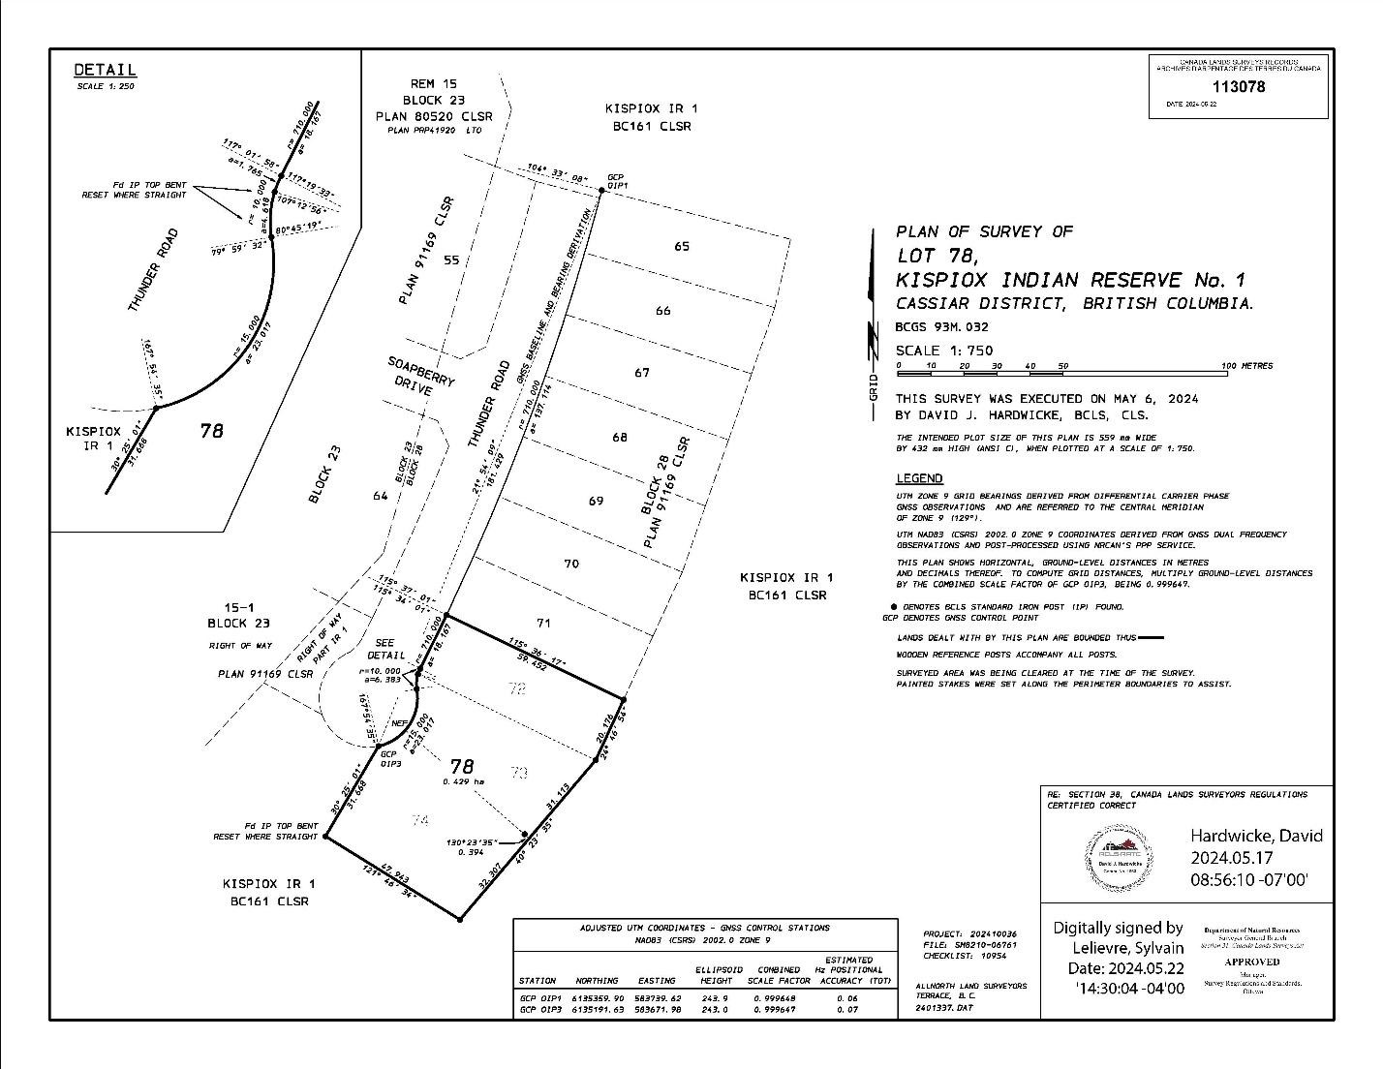**Map of the Proposed Designated Lands**